All rest calls are open wihtout any password restriction

1. Booklist REST call:

Method:

GET

<http://localhost/bookstore/public/booklist>

**optional parameters**

name, category, order, page

**Output:**

{

"error": false,

"urls": [

{

"book_id": 1,

"category_id": 2,

"book_name": "asdasdas",

"book_author": "asdasd",

"book_description": "asdasd",

"book_price": 23,

"book_releasedby": "0000-00-00",

"book_publisher": "sadas",

"book_cover_pic": "",

"book_added_date": "2016-04-07 13:32:42",

"book_status": "available",

"category": "\r\nSatire"

},

{

"book_id": 2,

"category_id": 16,

"book_name": "sdasd",

"book_author": "asdas",

"book_description": "asdasd",

"book_price": 20,

"book_releasedby": "0000-00-00",

"book_publisher": "ddd",

"book_cover_pic": "1460021891235161.jpg",

"book_added_date": "2016-04-07 13:38:11",

"book_status": "available",

"category": "History"

},

{

"book_id": 3,

"category_id": 3,

"book_name": "Patrick Hemsworth, Sydney",

"book_author": "dasd",

"book_description": "sdasdasda",

"book_price": 0,

"book_releasedby": "0000-00-00",

"book_publisher": "dasda",

"book_cover_pic": "1460028571235161.jpg",

"book_added_date": "2016-04-07 15:29:31",

"book_status": "available",

"category": "Drama"

},

{

"book_id": 4,

"category_id": 1,

"book_name": "TIger manrathon",

"book_author": "sathish",

"book_description": "fantastic",

"book_price": 300,

"book_releasedby": "2016-04-13",

"book_publisher": "dasda",

"book_cover_pic": "14600542037Lsr3VLzNVdIPxcSyeP06fIqaoLIJyc7I2PXBa58zb0.jpg",

"book_added_date": "2016-04-07 22:36:43",

"book_status": "available",

"category": "Science fiction"

}

]

}

Screen:

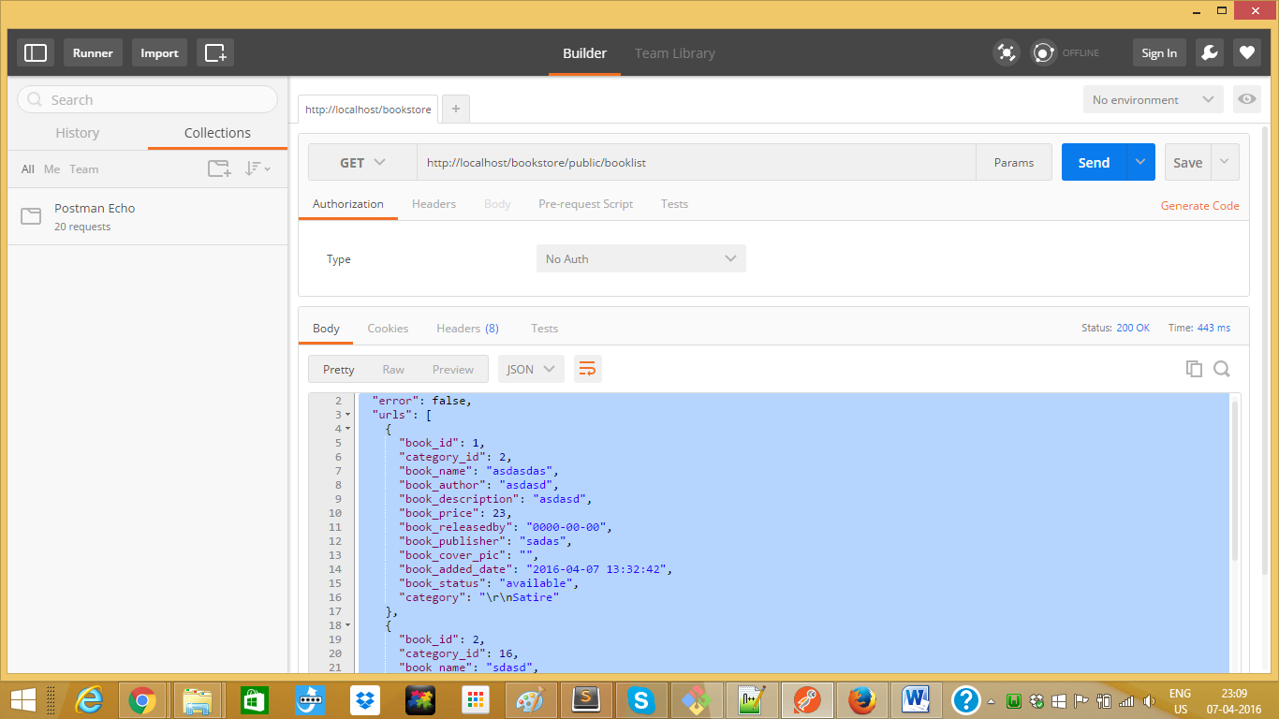

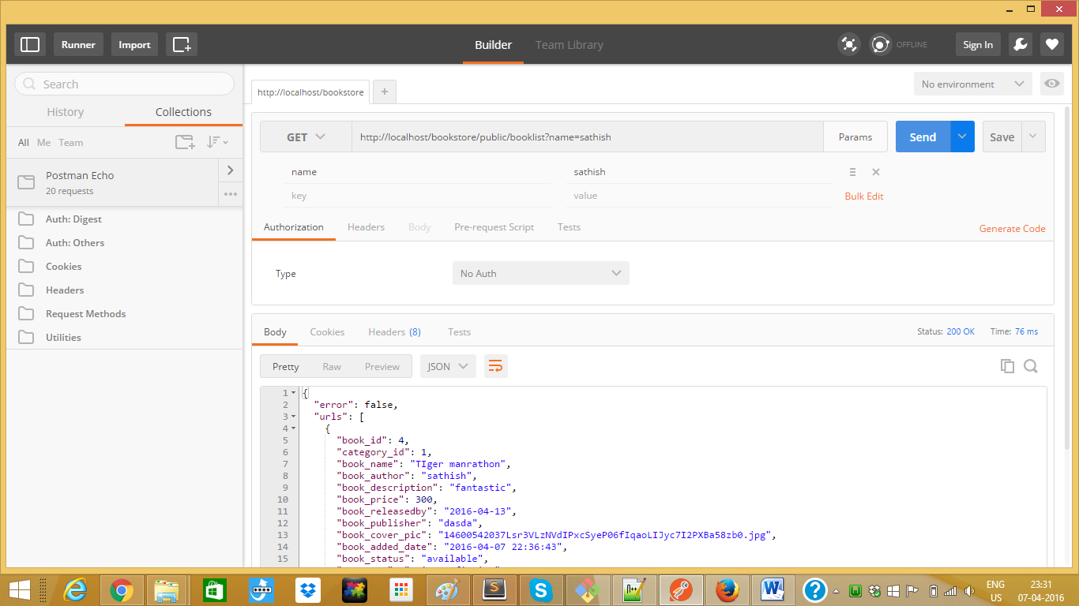

2) Book detailed view

Method: get

<http://localhost/bookstore/public/bookviewrest/1>

{

"error": false,

"urls": {

"book_id": 1,

"category_id": 2,

"book_name": "asdasdas",

"book_author": "asdasd",

"book_description": "asdasd",

"book_price": 23,

"book_releasedby": "0000-00-00",

"book_publisher": "sadas",

"book_cover_pic": "",

"book_added_date": "2016-04-07 13:32:42",

"book_status": "available",

"category": "\r\nSatire"

}

}

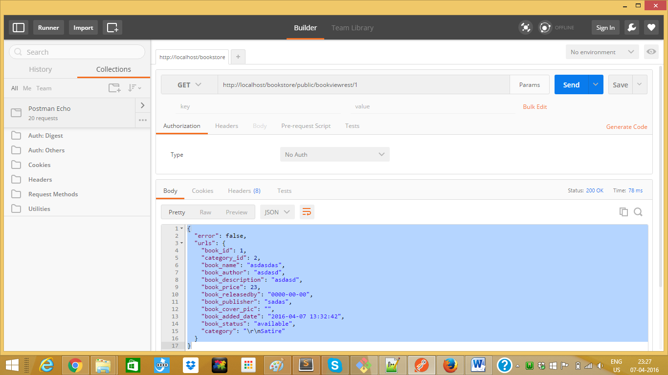

1. Book categories list

Method: get

http://localhost/bookstore/public/category

Otput:

{

"error": false,

"urls": [

{

"category_id": 1,

"category": "Science fiction"

},

{

"category_id": 2,

"category": "\r\nSatire"

},

{

"category_id": 3,

"category": "Drama"

},

{

"category_id": 4,

"category": "Action and Adventure"

},

{

"category_id": 5,

"category": "Romance"

},

{

"category_id": 6,

"category": "Mystery"

},

{

"category_id": 7,

"category": "Horror"

},

{

"category_id": 8,

"category": "Self help"

},

{

"category_id": 9,

"category": "Health"

},

{

"category_id": 10,

"category": "Guide"

},

{

"category_id": 11,

"category": "Travel"

},

{

"category_id": 12,

"category": "Children's"

},

{

"category_id": 13,

"category": "Religion"

},

{

"category_id": 14,

"category": "Spirituality & New Age"

},

{

"category_id": 15,

"category": "Science"

},

{

"category_id": 16,

"category": "History"

},

{

"category_id": 17,

"category": "Math"

},

{

"category_id": 18,

"category": "Anthology"

},

{

"category_id": 19,

"category": "Poetry"

},

{

"category_id": 20,

"category": "Encyclopedias"

},

{

"category_id": 21,

"category": "Dictionaries"

},

{

"category_id": 22,

"category": "Comics"

},

{

"category_id": 23,

"category": "Art"

},

{

"category_id": 24,

"category": "Cookbooks"

},

{

"category_id": 25,

"category": "Diaries"

},

{

"category_id": 26,

"category": "Journals"

},

{

"category_id": 27,

"category": "Prayer books"

},

{

"category_id": 28,

"category": "Series"

},

{

"category_id": 29,

"category": "Trilogy"

},

{

"category_id": 30,

"category": "Biographies"

},

{

"category_id": 31,

"category": "Autobiographies"

},

{

"category_id": 32,

"category": "Fantasy "

},

{

"category_id": 33,

"category": "Others"

}

]

}

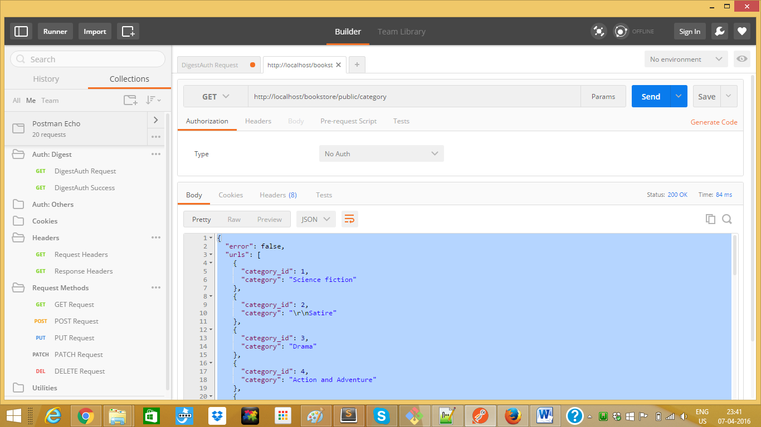

1. Add Book Rest API

Method: get

<http://localhost/bookstore/public/addbookrest>

required paramters:

name (string), category(id), author(string)

optional parameters:

coverpic(file input),description (string), price (integer), publish_date (date format), publisher (string)

output:

{"error":false,"message":"Successfully added books","bookid":6}

